**A PROJECT REPORT ON**

**ALCOHOL DETECTON WITH VEHICLE CONTROLLING**

SUBMITTED TO THE UNIVERSITY OF PUNE, PUNE

IN THE PARTIAL FULFILLMENT FOR THE SUBJECT “ MINI PROJECT AND SEMINAR”

**OF**

**TE – E&TC ( SEM – II )**

**BY**

|  |  |  |
| --- | --- | --- |
| **SNEHA BHAMBURE** | **Exam. No. :** | **T80363036** |
| **SONALI BORKAR** | **Exam. No. :** | **T80363050** |
| **KISHOR MITTAL** | **Exam No. :** | **T80363221** |

**UNDER THE GUIDANCE OF**

**Prof. V.T. THITE**



**DEPARTMENT OF ELECTRONICS AND TELECOMMUNICATION** **ENGG**.

**STES’S**

**SMT. KASHIBAI NAVALE COLLEGE OF ENGINEERING**

**VADGAON BK., OFF. SINHGAD ROAD**

**PUNE 411041**

**2013 - 2014**

|  |  |  |
| --- | --- | --- |
|  |  |  |
|  |  |  |

B) CERTIFICATE

**CERTIFICATE**

This is to certify that the project report entitled

*ALCOHOL DETECTION WITH VEHICLE CONTROLLING*

**Submitted by**

|  |  |  |
| --- | --- | --- |
| **SNEHA BHAMBURE** | **Exam. No. :** | **T80363036** |
| **SONALI BORKAR** | **Exam. No. :** | **T80363050** |
| **KISHOR MITTAL** | **Exam No. :** | **T80363221** |

is a bonafide work carried out by them under the supervision of **Prof. V.T.TITHE**  and it is approved for the partial fulfillment of the requirement of University of Pune for the subject “ Mini Project and Seminar” of TE ( E&TC)

This project report has not been earlier submitted to any other Institute or University for the award of any degree or diploma*.*

|  |  |  |
| --- | --- | --- |
| **Prof. V.T. TITHE** | **Prof. S.M. Ingawale** | **Prof. Dr.A.V.Deshpande** |
| **Guide** | **Head** | **Principal** |
| Department of E&T/C | Department of E&T/C | S.K.N.C.O.E,Pune-41 |
| S.K.N.C.O.E,Pune-41 | S.K.N.C.O.E,Pune-41 |  |

Place: Pune

Date :

**ACKNOWLEDGEMENT**

We would like to extend our acknowledgement to certain people who have been helpful and without whom this project would not have been a success .

We would express our profound gratitude to our project guide Prof. V.T. THITE in particular for her inspiring guidance which led to the development of the project.

We would also like to thank Prof. S.M. Ingawale ,head of department ,E & tc for helping us in a successful completion of our project.

**BY:**

SNEHA BHAMBURE

SONALI BORKAR

KISHOR MITTAL

|  |  |  |
| --- | --- | --- |
|  |  |  |
|  |  |  |

**CONTENTS**

CERTIFICATE

ACKNOWLEDGEMENT

LIST OF FIGURES  *I*

LIST OF TABLES  *II*

NOMENCLATURE  *III*

|  |  |  |  |  |
| --- | --- | --- | --- | --- |
| **CHAPTER** | | | **TITLE** | **PAGE NO.** |
|  |  |  | ORGANIZATION OF REPORT |  |
| 1 |  |  | INTRODUCTION |  |
|  | 1.1 |  | INTRODUCTION OF PROJECT |  |
|  | 1.2 |  | OBJECTIVE OF PROJECT |  |
| 2 |  |  | LITERATURE SURVEY |  |
|  | 2.1 |  | INTRODUCTION |  |
|  |  | 2.1.1 | ISSUES |  |  | 1.3.3 | DESIGN ASPECT |  |
|  |  | 2.1.2 | **APPROACH** |  |
|  |  | 2.1.3 | OVERVIEW OF REPORT |  |
| 3 |  |  | DESIGN ASPECT |  |
|  | 3.1 |  | INTRODUCTION |  |

|  |  |  |  |  |  |  |  |  |  |  |  |
| --- | --- | --- | --- | --- | --- | --- | --- | --- | --- | --- | --- |
|  | | | | | | | | |  |  | |
|  | | | | | | | |  |  | | |
|  | 3.1 |  | INTRODUCTION |  |
|  |  | 3.1.1. | BLOCK DIAGRAM DESCRIPTION |  |
|  |  | 3.1.2 | POWER SUPPLY DESIGN |  |
|  |  | 3.1.3 | POWER SUPLY DESIGN OF THE PROJECT |  |
|  |  | 3.1.4 | **The reason to choose rectifier** |  |
|  |  | 3.1.5 | Specification |  |
|  | 3.2 |  | FLOWCHART |  |
|  | 3.3 |  | CODE |  |
|  | 3.4 |  | SOFTWARE DESIGN |  |
|  |  |  |  |  |
|  |  |  |  |  |
| 4 |  |  | **IMPLEMENTATION AND TESTING** |  |
|  | 4.1 |  | CIRCUIT DIAGRAM |  |
|  | 4.2 |  | IMPLEMENTATION |  |
|  | 4.3 |  | PCB MAKING PROCESS SNAPSHOT |  |
|  | 4.4 |  | PCB LAYOUT |  |
|  | 4.5 |  | FINAL PROJECT SNAPSHOT |  |
|  |  |  |  |  |
| 5 |  |  | **ADTVANTAGES , DISADVANTAGESAND APPLICATIONS** |  |
|  | 5.1 |  | ADVANTAGES |  |
|  | 5.2 |  | DISADVANTAGES |  |
|  | 5.3 |  | APPLICATIONS |  |
|  |  |  |  |  |
| 6 |  |  | **RESULT,DISCUSSION AND FUTURE SCOPE** |  |
|  | 6.1 |  | RESULT |  |
|  | 6.2 |  | FUTURE SCOPE |  |
|  | 6.3 |  | DISCUSSION |  |
|  |  |  |  |  |
| 7 |  |  | REFERENCES |  |
|  |  | 7.1 | **REFERENCE BOOK’S** |  |
|  |  | 7.2 | **WEB REFERENCES** |  |
|  |  |  |  |  |
|  |  |  | BILL OF MATERIAL |  |
|  |  |  | **DATASHEETS** |  |
|  |  |  |  |  |

**ORGANIZATION OF REPORT**

This project consists of 7 chapters which gives us a brief idea about the project such as basic information design and implementation.

1. **INTRODUCTION**
2. **LITERATURE SURVEY**
3. **DESIGN ASPECT**
4. **IMPLEMENTATION AND TESTING**
5. **RESULT AND DISCUSSIONS**
6. **ADVANTAGES,DISADVANTAGES AND APPLICATION.**
7. **REFERENCE**

**1. INTRODUCTION**

In this chapter, overall study of the project is discussed .The motivation and objectives of the project has been discussed. General specifications of project are discussed.

2. **LITERATURE SURVEY**

In this chapter the general introduction to the field of alcohol detection with vehicle controlling system with an overview of history of the same is discussed. The block diagram of each section is described briefly.

**3. DESIGN ASPECT**

In this chapter all the design aspects are taken under consideration. The design and working of each block has been discussed in this chapter. The specifications and description of all the blocks are given in short. The software aspect of the system is discussed shortly in this chapter.

**4 IMPLEMENTATION AND TESTING**

In this chapter fabrication of PCBs and testing and troubleshoot condition of the system have been studied. The flowchart of PCB fabrication has been studied in this chapter.

**5. RESULT AND DISCUSSION:**

In this chapter, the final result after the successful working of the project has been described with discussion of topics related to the project.

**6. ADVANTAGES , DISADVANTAGES AND APPLICATIONS:**

In this chapter, the merits and demerits of the project has been discussed considering various application and future scope of the project.

**7.REFERENCES:**

It includes a list of all books, software used in designing, implementation of our project . All website referred are also listed below.

**CHAPTER 1**

**INTRODUCTION**

* 1. **INTRODUCTION OF THE PROJECT**

It gives us immense happiness to present before you the project which is **‘ALCOHOL DETECTION WITH VEHICLE CONTROLLING’** as part our curriculum for T.E in

E & TC. This project report is used for detecting the alcohol drunken people Software requirement is **Protieus.** This project is also helpful in detecting the exact consumption of alcohol taken by the person. This will help in taking strict action required at that moment.

So for detecting alcohol drunken people , we have to use microcontroller(89S52), alcohol sensor(MQ3), buzzer, relay , ADC, LCD.

As part of the SAFETEA-LU legislation, the Secretary of Transportation was directed to conduct a study on the potential for reducing the incidence of alcohol-related motor vehicle crashes and fatalities through advanced vehicle-based alcohol detection systems.

Also included is an assessment of the practicability and effectiveness of such systems.[6] NHTSA’s Office of Human-Vehicle Performance Research has tasked the Volpe National Transportation Systems Center (Volpe Center) to assess the potential for vehicle-based technologies to prevent alcoholimpaired crashes.

The purpose of this TOPIC report is to identify vehicle-based technologies capable of detecting and preventing alcohol impaired driving. Research data will provide input to a report required to be submitted in 2007 to Congress.

**1.2 OBJECTIVES OF THE PROJECT**

The main objective of alcohol detector circuit project is to detect the alcohol drunken people. The basic idea behind the project is to reduce the drink and driving cases in city with alcohol detectors incorporated in vehicles. Now a days many accidents are reported. The percentage has been increased to a great level.

Another objective of this project is to provide a economical solution in the field of alcohol solution . Therefore our project is of great help in preventing drink and drive accidental case.

The National Highway Traffic Safety Administration's Office of Human-Vehicle Performance

Research tasked the Volpe National Transportation Systems Center (Volpe Center) of the U.S.

Department of Transportation’s Research and Innovative Technology Administration to identify

current and emerging vehicle-based technologies that can detect driver blood alcohol concentration (BAC) and monitor driver impairment due to alcohol. Detection technologies have the potential to prevent death and injury by monitoring BAC and/or driving performance for signs of impairment, and if necessary either prevent ignition or take other actions to prevent a crash.

As part of the SAFETEA-LU legislation, the Secretary of Transportation was directed to conduct a study on reducing the incidence of alcohol-related motor vehicle crashes and fatalities through research on advanced vehicle-based alcohol detection systems, including

an assessment of the practicability and effectiveness of such systems. In support of this

mandate, this report on Technology to Prevent Alcohol Impaired Crashes (TOPIC) assesses

the capability of existing and anticipated technologies to detect and prevent alcohol-impaired

driving. It also includes a concept of operations to describe how to implement technology-based

countermeasures while addressing concerns such as privacy, public acceptance, and legal issues.

**CHAPTER 2**

**LITERATUTRE SURVEY**

**2.1 INTRODUCTION**

**2.1.1 ISSUES**

* In 2004, the National Highway Traffic Safety Administration reported that there were 16,694deaths and 248,000 people injured as a result of alcohol-related motor vehicle crashes.[2, 3]
* Alcohol-related motor vehicle fatalities account for 39 percent of all motor-vehicle-related deaths.
* The NHTSA Administrator has stated that this fatality rate is a national concern during

her 2006 testimony to Congress, referring to the provisions in the Safe, Accountable, Flexible, Efficient Transportation Equity Act: A Legacy For Users (SAFETEA-LU) legislation to provide increased funding to reduce impaired driving.

* Fatalities and injuries due to motor vehicle crashes create particularly heavy losses to society when expressed as disability-adjusted life-years (DALYs), because the motor vehicle crash victims tend to be young. (DALYs tabulate the number of years lost to premature death and disabling injuries.) The public health community is increasingly aware of the losses world-wide due to vehicle accidents and forecasts that vehicle accidents will move from the ninth cause of DALYS in 1990 to the third leading cause by 2020. [4] The 16 to 20 and 20 to 24 age groups have the highest fatality rate per 100,000 -- more than double the rate for the overall population,[5] with a substantial proportion of these crashes being alcohol-related.
  + 1. **APPROACH**
* Impairment detection technologies have the potential to prevent serious crashes by stoppingimpaired drivers from starting or operating vehicles.
* Technology can detect driver BAC and lock out the driver or monitor driving performance for signs of impairment.
* If driver impairment is evident, the system can warn the driver and or impose any of a range of measures to mitigate risk..
* This report assesses the ability of technologies, existing and anticipated, to detect driver
* impairment from alcohol and identifies international state-of-the-art vehicle-based technology options to prevent alcohol-impaired automotive crashes.
* This analysis was carried out with the support of the Intelligent Vehicle Initiative (IVI) program, created in 1998 as part of the Department of Transportation ITS program.
* The IVI program focuses on the collision warning system as an effective tool to reduce the number of accidents by providing effective and timely warnings to drivers.
* The Volpe Center team interviewed stakeholders and interested parties and reviewed research results to assess the capability of vehicular technologies to reduce alcohol-impaired driving.
* The team acquired academic expertise both to review post-1995 literature and to identify international sources of expertise for vehicle-based alcohol impairment detection.
* The research team collaborated with European experts to acquire first-hand information about the results of the EU projects: System for the Effective Assessment of the Driver State and Vehicle Control in Emergency Situations (SAVE) and System for Effective Assessment of Driver Vigilance and Warning According to Traffic Risk Estimation (AWAKE), the plans and intent of the EU project Advanced Sensor Development for Attention, Stress, Vigilance and Sleep/Wakefulness Monitoring (SENSATION), and the status of relevant research by European institutes on vehicle-based alcohol impairment identification and countermeasures.
* In addition, the European collaborator conducted personal interviews with six major European stakeholders representing technology developers such as original equipment manufacturers and suppliers and EU government agencies about vehicle-based alcohol impairment identification and countermeasures.

**2.1.3 OVERVIEW OF REPORT**

* This report describes the most effective means of measuring alcohol impairment and the strategies for implementing technology-based countermeasures.
* The report estimates the potential for crash reductions as a result of introducing TOPIC in relation to fatalities and injuries avoided; describes the strengths and weaknesses of near-term approaches, including breath alcohol ignition interlock devices (BAIID) for DUI offenders; evaluates current and emerging crash avoidance technologies; identifies cross-cutting implementation issues likely to accompany the introduction of these technologies; identifies research needs; and provides a concept of operations using promising technologies.

**CHAPTER 3**

**DESIGN ASPECT**

**3.1 INTRODUCTION**

Here we have discussed the basic block diagram of the alcohol detector as shown below.

**3.1.1 BLOCK DIAGRAM DESCRIPTION**

**a)LIQUID CRYSTAL DISPLAY:**

* LCD is used in a project to visualize the output of the application.
* We have used 16x2 LCD which indicates 16 columns and 2 rows. So, we can write 16 characters in each line. So, total 32 characters we can display on 16x2 LCD.
* LCD can also used in a project to check the output of different modules interfaced with the microcontroller.
* Thus LCD plays a vital role in a project to see the output and to debug the system module wise in case of system failure in order to rectify the problem.

**b) BUZZER:**

* Buzzer or beeper is an audio signaling device, which may be mechanical, electromechanical, or piezoelectric.
* Typical uses of buzzers and beepers include alarm devices, timers and confirmation of user input such as a mouse click or keystroke.

**c) ALCOHOL SENSOR:**

* Alcohol sensor is used to detect weather the person have consumed the alcohol or not.
* The sensor which we have used is MQ3 sensor.
* **HOW MQ3 SENSOR WORK’s:**
* MQ3 sensor is an analog sensor and the output is in analog form.
* So the output of this sensor is provided to the input of the ADC which will convert this analog output in digital input to the microcontroller.Sensitive material of MQ-3 gas sensor is SnO2, which with lower conductivity in clean air.
* When the target alcohol gas exist, The sensor’s conductivity is more higher along with the gas concentration rising.
* Please use simple electro circuit, Convert change of conductivity to correspond output signal of gas concentration.MQ-3 gas sensor has high sensitivity to Alcohol, and has good resistance to disturb of gasoline, smoke and vapour.
* The sensor could be used to detect alcohol with different concentration; it is with low cost and suitable for different application

**3.1.2 POWER SUPPLY:**

* The basic step in the designing of any system is to design the power supply required for that system.
* The steps involved in the designing of the power supply are as follows,

) Determine the total current that the system sinks from the supply.

2) Determine the voltage rating required for the different components.

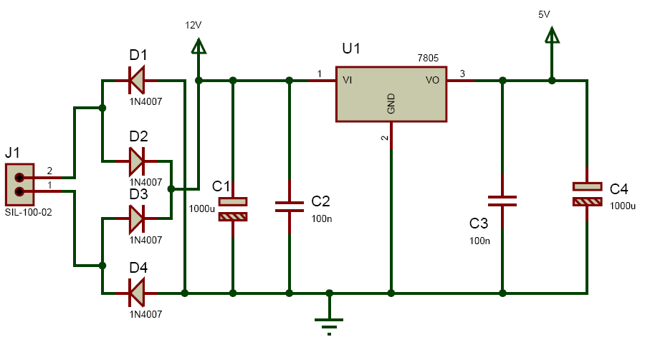

* The bridge rectifier and capacitor i/p filter produce an unregulated DC voltage which is applied at the I/P of 7805.As the minimum dropout voltage is 2v for IC 7805, the voltage applied at the input terminal should be at least 7 volts .
* C1 (1000 µf / 65v)is the filter capacitor and C2 and C3 (0.1 pf) is to be connected across the regulator to improve the transient response of the regulator.
* Assuming the drop out voltage to be 2 volts, the minimum DV voltage across the capacitor C1 should be equal to 7volts (atleast).

**3.1.3 Power supply design of the Project :**

* The average voltage at the output of a bridge rectifier capacitor filter combination is given by
* Vin(DC) = Vm – Idc / 4 f C1
* Where , Vm=√2 Vs and Vs = rms secondary voltage
* Assuming Idc to be equal to max. load current, say 100Ma

C = 1000 uf / 65v , f=50hHz

15 = Vm – 0.1 / 4*50*1000*10¯6

15= Vm – 0.1 / 0.2

Vm=15.5 volts

* Hence the RMS secondary Voltage
* Vrms = Vm / √2

= 15.5 / √2

=15.5 / 1.41421

=10.9601 volts

* So we can select a 15v secondary Voltage In our system most of the components require 5 V as operating voltage such as micro controller, MAX 232, LCD etc.
* The total current, which our circuit sinks from the power supply, is not more than 100 mA. We have used Regulator IC 7805 that gives output voltage of 5V.
* The minimum input voltage required for the 7805 is near about 7 v. Therefore we have used the transformer with the voltage rating 230v-10v and current rating 500/750 mA.
* The output of the transformer is 12 V. This voltage is converted into 12 V DC by Bridge rectifier circuit.

**3.1.4 The reasons for choosing the bridge rectifier are**

1. The TUF is increased to 0.812 as compared the full wave rectifier.
2. The PIV across each diode is the peak voltage across the load =Vm, not 2Vm as in the two diode rectifier

* Output of the bridge rectifier is not pure DC and contains some AC some AC ripples in it.
* To remove these ripples we have used capacitive filter, which smoothens the rippled out put that we apply to 7805 regulators IC that gives 5V DC.
* We preferred to choose capacitor filters since it is cost effective, readily available and not too bulky.
  + 1. **Microcontroller (89S52)** :

SPECIFICATIONS

1. **HARDWARE:**

Features

• Compatible with MCS-51® Products

• 8K Bytes of In-System Programmable (ISP) Flash Memory

– Endurance: 1000 Write/Erase Cycles

• 4.0V to 5.5V Operating Range

• Fully Static Operation: 0 Hz to 33 MHz

• Three-level Program Memory Lock

• 256 x 8-bit Internal RAM

• 32 Programmable I/O Lines

• Three 16-bit Timer/Counters

• Eight Interrupt Sources

• Full Duplex UART Serial Channel

• Low-power Idle and Power-down Modes

• Interrupt Recovery from Power-down Mode

• Watchdog Timer

• Dual Data Pointer

• Power-off Flag

• Fast Programming Time

• Flexible ISP Programming (Byte and Page Mode)

1. **SOFTWARE:**

* Keil uV2 Software for Programming

PIN DIAGRAM FOR MICROCONTROLLER:

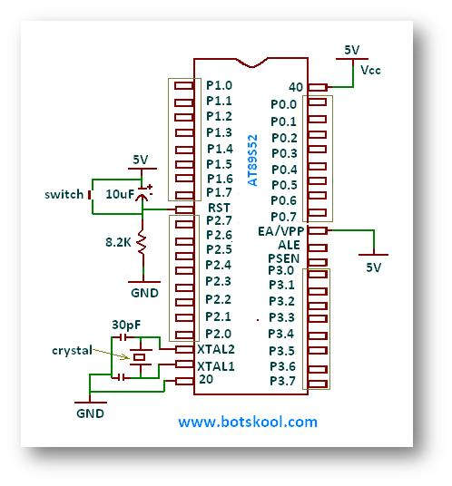

**3.2 FLOWCHART**

INITIALIZE LCD

DISPLAY PROJECT NAME

SELECT CHANNEL 1 11

READ ADC

STORE AND DISPLAY THE ALCOHOL ON LCD

IS ALCOHOL

GREATER THAN 90

Yes NO

RELAY ON

BUZZER OFF

RELAY OFF

BUZZER ON

Fig no 2: Microcontroller circuit diagram

**3.3 CODE:**

**LCDRS BIT P1.0**

**LCDRW BIT P1.1**

**LCDEN BIT P1.2**

**LCDDATA EQU P0**

**R_D BIT P3.7 ;2**

**W_R BIT P3.6 ;3**

**INTR BIT P3.5 ;5**

**ADCPORT EQU P2**

**BUZZER bit P1.3**

**RELAY bit P3.4**

**CM BIT 0**

**bit1 bit 1**

**CNT EQU 30H**

**delr0 equ 40h**

**delr1 equ 41h**

**delr2 equ 42h**

**delr3 equ 43h**

**CMP equ 44h**

**org 0000h**

**ajmp over**

**org 0050h**

**over:**

**//MSG1: DB 'Alcohol Detection'**

**//MSG2: DB ' in car '**

**SETB RELAY**

**setb buzzer**

**ACALL LCDINIT**

**ACALL CLEAR**

**mov dptr,#MSG1**

**mov R7,#16**

**ACALL DISP_MSG**

**MOV A,#0C0H**

**ACALL COMMAND**

**mov dptr,#MSG2**

**mov R7,#16**

**ACALL DISP_MSG**

**ACALL DELAY**

**AGN:**

**agn1:**

**ACALL READ_ADC**

**ACALL DISPPARA**

**MOV A,CMP**

**mov b,#2**

**div ab**

**cjne a,#30,x1**

**x1: jc nomsg**

**mov a,#0c0h**

**acall command**

**mov dptr,#MSGg //msgg: db 'Alco. Detected '**

**mov R7,#16**

**ACALL DISP_MSG**

**clr buzzer**

**acall delay**

**acall delay**

**acall delay**

**acall delay**

**CLR RELAY**

**x2:**

**ACALL DELAY**

**AJMP AGN**

**nomsg:**

**clr bit1**

**acall delay**

**SETB RELAY**

**setb buzzer**

**AJMP AGN**

**msgg: db 'Alco. Detected '**

**READ_ADC:**

**MOV ADCPORT,#0FFH //P2**

**CLR W_R //SOC**

**NOP**

**NOP**

**NOP**

**NOP**

**NOP**

**NOP**

**SETB W_R**

**SETB INTR //EOC**

**HRE: JB INTR,HRE**

**CLR R_D**

**NOP**

**NOP**

**NOP**

**NOP**

**MOV A,ADCPORT**

**SETB R_D**

**MOV CMP,A**

**RET**

**DISPPARA:**

**ACALL CLEAR**

**mov dptr,#LEVL**

**mov R7,#16**

**ACALL DISP_MSG**

**MOV A,#89H**

**ACALL COMMAND**

**MOV A,CMP**

**mov b,#2**

**div ab**

**ACALL HTB**

**mov a,#' '**

**ACALL DISPLAY**

**mov a,#'m'**

**ACALL DISPLAY**

**mov a,#'l'**

**acall DISPLAY**

**RET**

**HTB:**

**MOV B,#64H**

**DIV AB**

**ACALL DISPLAY1**

**MOV A,B**

**MOV B,#0AH**

**DIV AB**

**ACALL DISPLAY1**

**MOV A,B**

**ACALL DISPLAY1**

**RET**

**LEVL: DB 'Alcohol: '**

**lcdINIT:**

**mov a,#38h**

**acall command**

**mov a,#0eh**

**acall command**

**mov a,#06h**

**acall command**

**clear:**

**mov a,#01h**

**acall command**

**ret**

**;lcd strobe subroutine**

**command:**

**acall ready**

**mov LCDDATA,a**

**clr LCDRS**

**clr LCDRW**

**setb LCDEN**

**clr LCDEN**

**ret**

**display1:**

**add a,#30h**

**display:**

**acall ready**

**mov LCDDATA,a**

**setb LCDRS**

**clr LCDRW**

**setb LCDEN**

**clr LCDEN**

**ret**

**ready:**

**clr LCDEN**

**mov LCDDATA,#0ffh**

**clr LCDRS**

**setb LCDRW**

**;----------------**

**wait:**

**clr LCDEN**

**setb LCDEN**

**jb LCDDATA.7,wait**

**clr LCDEN**

**ret**

**disp_msg:**

**mov r6,#00h**

**LO1: MOV A,R6**

**MOVC A,@A+DPTR**

**ACALL DISPLAY**

**INC R6**

**DJNZ R7,LO1**

**RET**

**delay: mov DELR0,#10**

**AJMP HER2**

**DB_delay:mov DELR0,#4**

**her2: mov DELR1,#254**

**her1: mov DELR2,#254**

**her: djnz DELR2,her**

**djnz DELR1,her1**

**djnz DELR0,her2**

**ret**

**MSG1: DB 'Alcohol Detection'**

**MSG2: DB ' in car '**

**end**

**3.4 SOFTWARE DESIGN**

MIDE tool for the 8052 Microcontroller Architecture support every level of software developer from the professional applications engineer to the student just learning

about software development.

**CHAPTER 4**

**IMPLEMENTATION AND TESTIN**

**4.1 CIRCUIT DIAGRAM:**

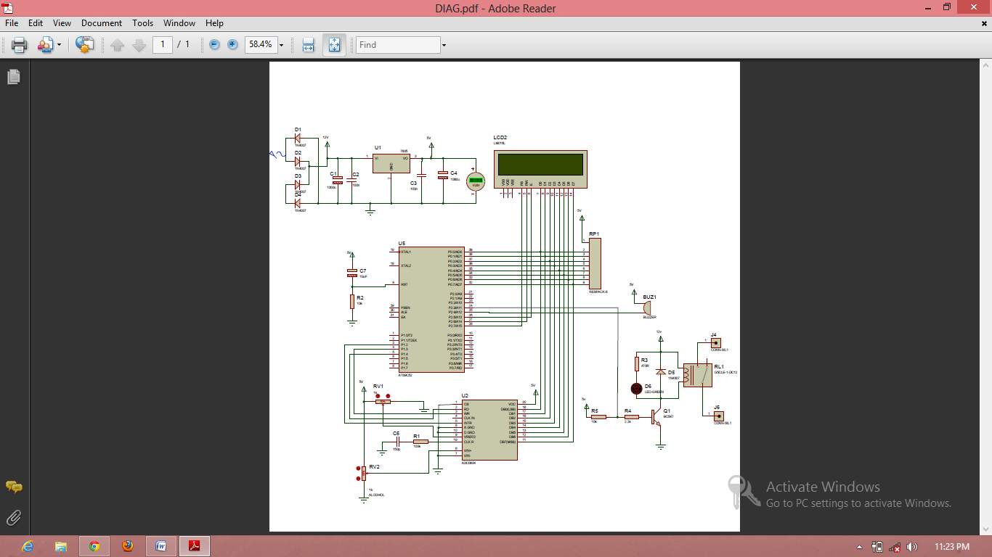

**4.2 IMPLEMENTATION**

* The most important requirement of this project was to build a PCB with minimum weight and size. A zero PCB is a drilled board. Drilling process removes a lot of material from board and weight is reduced .Designing procedure is as follows:

i. Decide a proper place for components

ii. Actual placements of components from zero PCB

iii. Connecting tracks with solid wires

**4.3 PCB MAKING PROCESS SNAPSHOTS:**

* 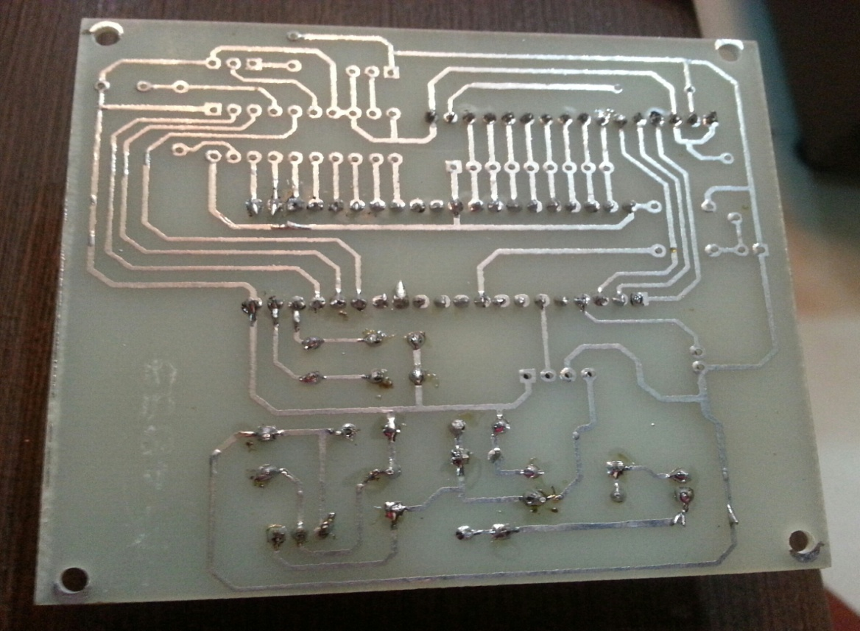

**4.4 PCB LAYOUTS**

* 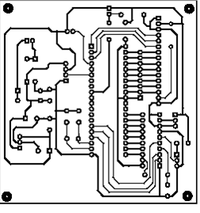

**4.5 FINAL PROJECT SNAPSHOTS**

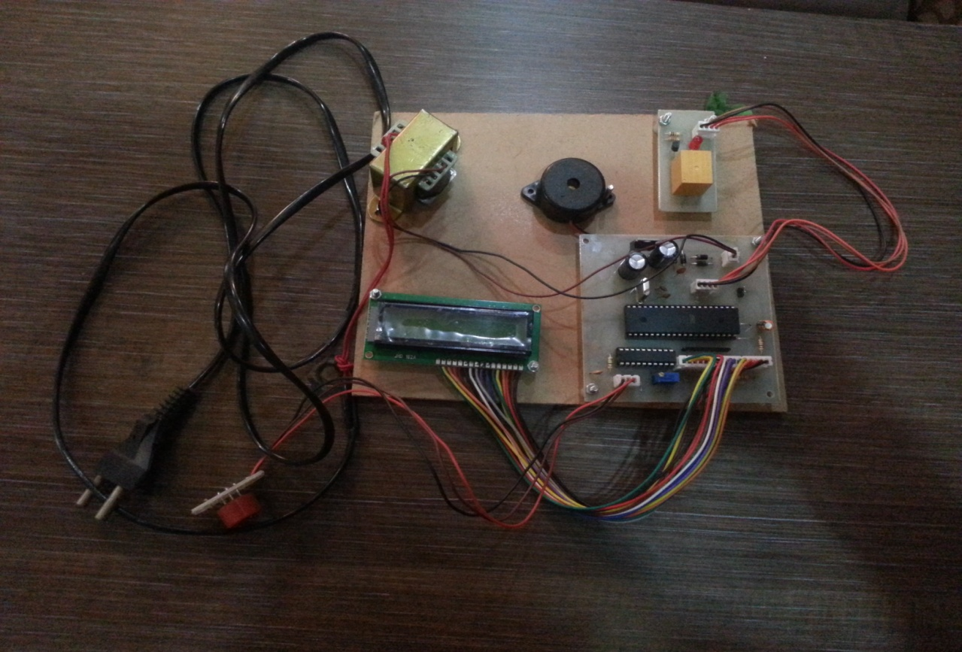

**PCB LAYOUT :**

* Layout basically means placing or arranging things in a specific order on the PCB.
* Layout means placing of components in an order. This placement is made such that the interconnection lengths are optimal .
* At the same time, it also aims at providing accessibility to the components for insertion testing and repair.
* The PCB layout is the starting point for the final artwork preparation layout design should reflect the concept of final equipment.
* There are several factors, which we must keep in mind for placing the layout.

**Schematic Diagram:**

* The schematic diagram forms main input document for preparation of the layout For this purpose the software for PCB design, ORCAD was used.

**Electrical and thermal requirement:**

* The PCB designer must be aware of the circuit performance in critical aspects of the same concerning electrical conditions and the environment to be used in.

**Mechanical requirement:**

* The designer should have the information about physical size of the board, type of installation of board (vertical/horizontal). The method of cooling adopted, front panel operated components etc.

**Component placing requirement:**

* All components are to placed first in a configuration that demands only the minimum length for critical conductors. These key components are placed first and the others are grouped around like satellites.

**Components mounting requirements:**

* All components must be placed parallel to one another as far as possible .i.e. in the same direction and orientation mechanical over stressing of solder should be avoided.

**Layout Methodology:**

* For proper layout design minimal steps to be followed are:
  + - Get the final circuit diagram and component list.
    - Choose the board types, single sided / double sided / multilayer
    - Identify the appropriate scale for layout.
    - Select suitable grid pattern.
    - Choose the correct board size keeping in view the constraints.
    - Select appropriate layout technique, manual / automated.
    - Document in the form of the layout scale.

**CHAPTER 5**

**ADVANTAGES, DISADVANTAGES AND APPLICATION**

**5.1 ADVANTAGES**

* Less time delays
* Quick response time
* Fully automate system
* Robust system
* Low power requirement
* Efficient
* Economical
* Time saving kit
* Portable
* It requires less space
* It can provide an automatic safety system for caes and other vehicles.

**5.2 DISADVANTAGES**

* Limited range.
* If any person other than the driver has consumed alcohol and if the system detects it even then it will not allow the car to start.
* Due to heating of coil in the sensor , the sensor takes time to initialize.

**5.3 APPLICATIONS**

* + - Drunk driving detection system is incorporated in vehicles.
    - Alcohol detector project can be used in various vehicles for detecting whether the driver has consumed alcohol or not
    - This project can also be used in various companies or organization to detect alcohol consumption of employees.
    - It can implement GSM technology to inform the relatives or owners of the vehicle about the alcohol consumption.
    - We can implement GPS technology to find the location of the

vehicle

**CHAPTER6**

**RESULT , DISCUSSION AND FUTURE SCOPE**

**6.1 RESULT:**

The main components in the project are described along with working which is useful to understand the project better and helps us in analyzing the scope and working.

Thus , the set point for alcohol consumption has been adjusted to 90ml.

As soon as the alcohol level in the vehicle crosses the set point , the buzzer starts buzzing which is an indication of danger . Similarly , as soon as the alcohol level in the vehicle drops below the set point , the buzzer automatically switches off.

**6.2 FUTURE SCOPE:**

1. In accident cases it is a very useful.
2. It is useful in identifying the culprit.
3. By modifying the circuit we can use it at professional level .
4. GSM technology can be implemented

**6.3 DISCUSSION:**

Blood alcohol concentration (BAC)is considered to be standard for measuring the degree to which an individual is impaired by alcohol .For years the study have shown that there is a direct correlation between the blood alcohol concentration and the degreevto which reactions and judgements are impaired.the methodology are used for blood alcohol testing is called gas chromatography.

**6.2 CONCLUSION:**

* We have successfully implemented ALCOHOL DETECTION WITH VEHICLE CONTROLLING
* With the help of this project the human efforts are largely reduced.
* It is the advanced technology which is rising rapidly

**CHAPTER7**

**REFERENCES**

**7.1 REFERANCES BOOKS**

Muhammad Ali Mazidi and Janice Gillispi Mazidi, ”The 8051 Microcontroller and Embedded systems”.

**7.2 WEBREFERENCES**

1. [http://www.datasheetcatalog.org/SGSThomsonMicroelec/mXtyyvx.pd](http://www.datasheetcatalog.org/SGSThomsonMicroelec/mXtyyvx.pdf)[f](f ii.       )
2. <http://www.8051projects.info/exp9.a>sp
3. <http://www.swedetrack.com/obstact.htm>

**BILL OF MATERIAL:**

|  |  |  |  |
| --- | --- | --- | --- |
| Name | Specification | Quantity | Prize |
| Liquid crystal display | 16*2 | 1 | 150 |
| Ceramic Capacitor | 33pf | 4 | 4 |
| Diode |  | 5 | 25 |
| Oscillator | 11.0592Mhz | 1 | 11 |
| Transistor | BC547 | 1 | 4 |
| Electrolytic capacitior |  | 2 | 6 |
| Alcohol sensor |  | 1 | 400 |
| 8051(AT89s51)  ADC | 0804 | 1  1 | 75  50 |
| Transformer |  | 1 | 200 |
| Resistor | 1k | 1 | 2 |
| Resistor: | 100k | 1 | 3 |
|  | 2.3k | 2 | 6 |
|  | 10k | 2 | 8 |